VizAlgo – PathFinder

Software Requirements Specification

Version  
1.0

Date  
December 30, 2019

Author  
Jonnelin Marzielli Leonardo

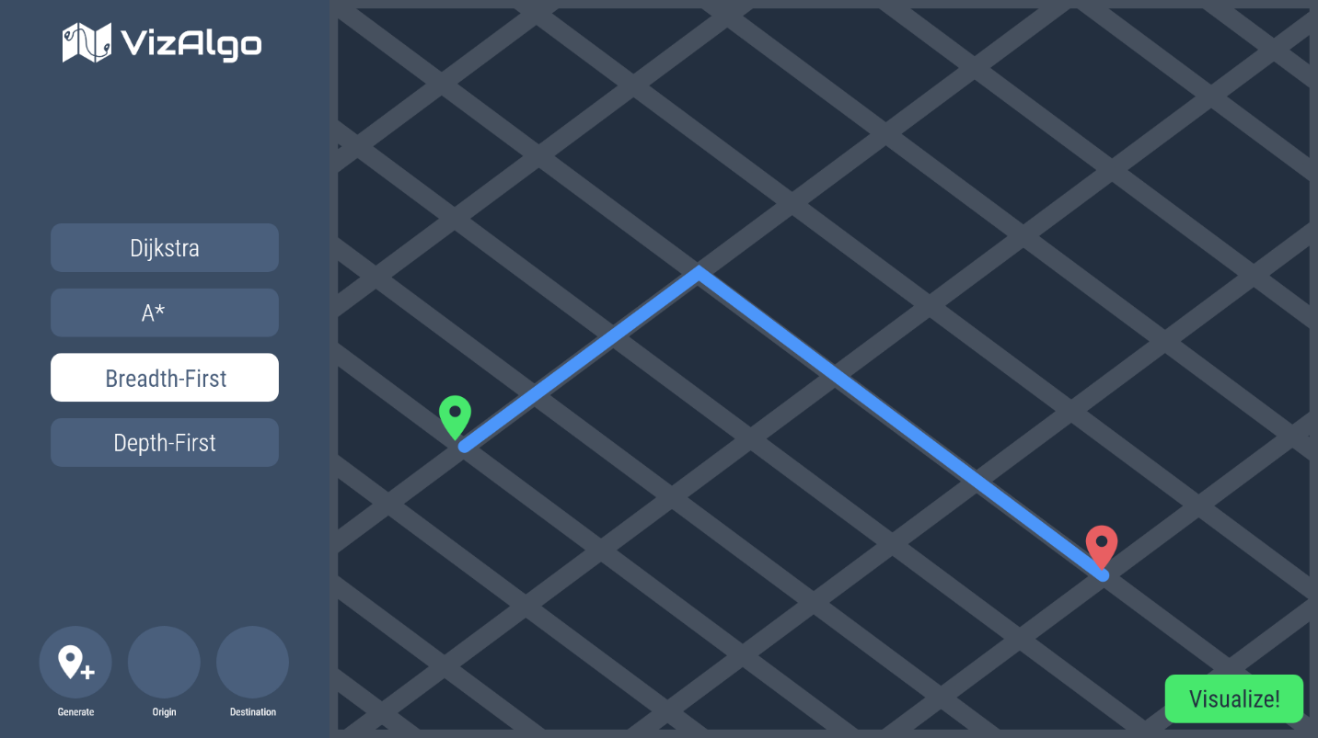

Table of Contents

Introduction 3

Purpose 3

Scope of Project 3

Glossary 3

Requirements Specification 4

Overview 4

Functional Requirements 4

Non-Functional Requirements 4

# Introduction

## Purpose

The purpose of this document is to describe an overview of the functionality of VizAlgo – Path Finder. This should give the reader an idea of what the user can do with this program.

## Scope of Project

Software which visualize pathfinding algorithms have been made; however, they often contain a large map with no routes, which is unrealistic. VizAlgo – Path Finder, shall allow users to be able to visually see the process of different pathfinding algorithms in more realistic, dynamically generated maps.

## Glossary

|  |  |
| --- | --- |
| **Term** | **Definition** |
| User | The end-user of the system |
| Algorithm | A process a system goes through or a solution used to complete a problem |
| Pathfinding Algorithm | An algorithm which discovers the most efficient path in a map or graph environment |
| Origin | The starting location in the map |
| Destination | The ending location in the map |

# Requirements Specification

## Overview

Below, the specified requirements, such as functionality, for the software are listed.

## Functional Requirements

|  |  |
| --- | --- |
| **ID** | **Requirement** |
| F01 | The user shall generate a map |
| F02 | The user shall choose an algorithm |
| F03 | The user shall choose an origin |
| F04 | The user shall choose a destination |
| F05 | The user shall click “Visualize Algorithm” button |
| F06 | Upon a user choosing an algorithm, the system shall give options such as Dijkstra, A*, Breadth-First, and Depth |
| F07 | Upon a user choosing an origin, the system shall allow the user to drag and drop a pin onto the map |
| F08 | Upon a user choosing a destination, the system shall allow the user to drag and drop a pin onto the map |
| F09 | Upon a user clicking the “Visualize Algorithm” button, the system shall graphically visualize routes traversed by the algorithm through map-like animations |

## Non-Functional Requirements

|  |  |
| --- | --- |
| N01 | The system shall handle errors such that it recovers from them, at at-most 10 seconds |